Shaimaa Said Soltan

1. Is the number of natural odd numbers == the number of natural even number?

To answer on this question, we must have symmetric function for all x values. And we have this function ; which is our f(x) = x but in higher dimension (2-D) nothing more.

point [A] : we have equal number of odd and even numbers.

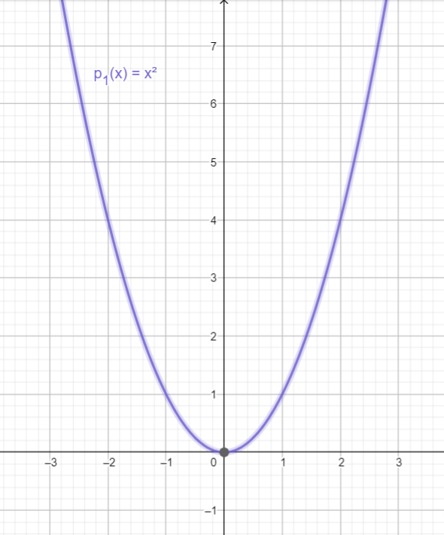

1. Based on point 1; then exactly Half of the number are odd natural number.

This means that ; Will have the same exact characteristics

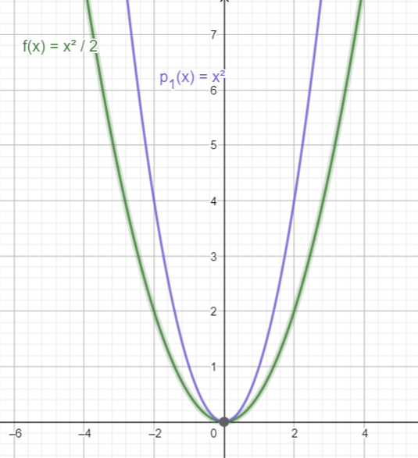but closer to [X] axis; as if we used division for linear function f(x) = x; f(x) = x/2 ; f(x) = x/4 ; f(x) = x/6 ; f(x) = x/8 each line is getting closer and closer to x axis so same will be in higher dimension 2-D for will be closer to [X] axis more than

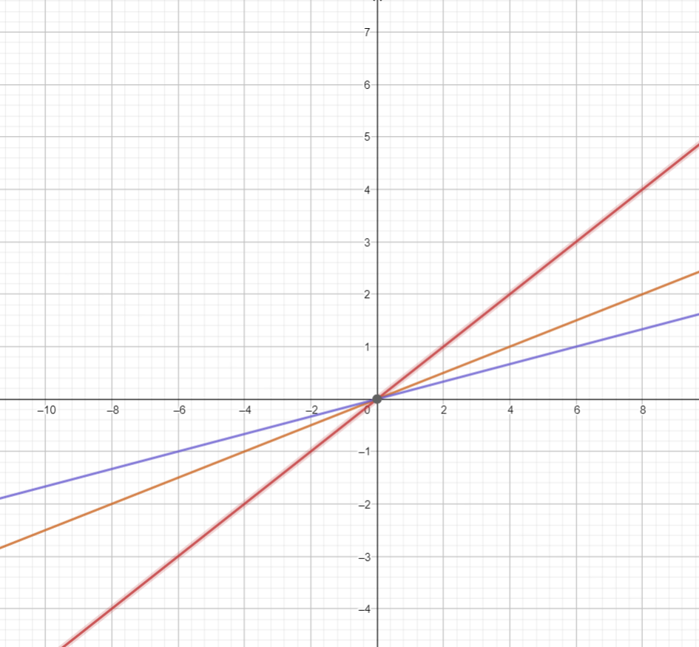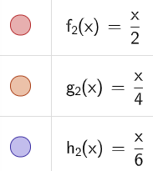

1. Sum of all natural numbers

Where N is any natural number from [0 , ∞]

And this is the shape of the sum it is quadratic equation with extremum at (-1/2 and -1/8).

If we want the sum of all natural number from 0 up untill nuatural number N we just draw line for X = N and the intersection point at q(X) will be the the sum from 0 up untill N.

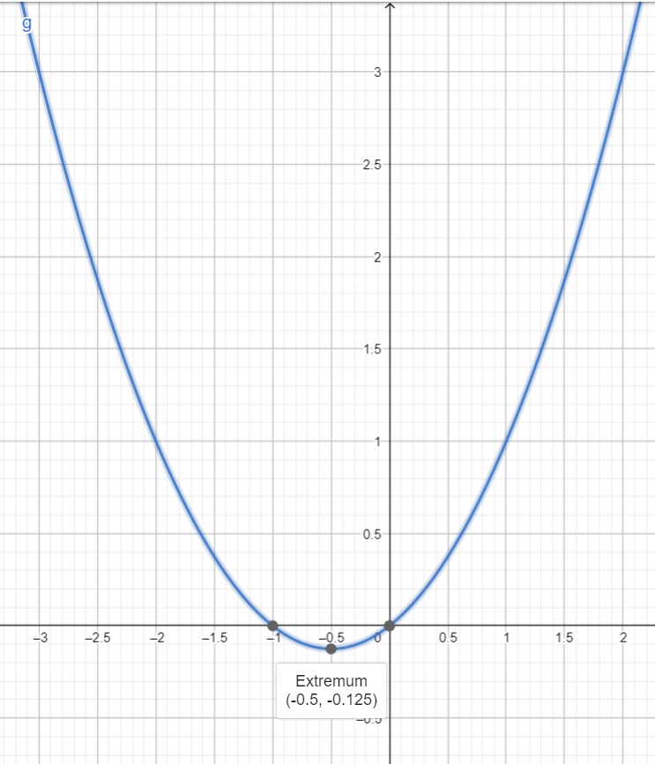

Sum of all number from 0 up untill 15 = intersection point with q(X) = 120

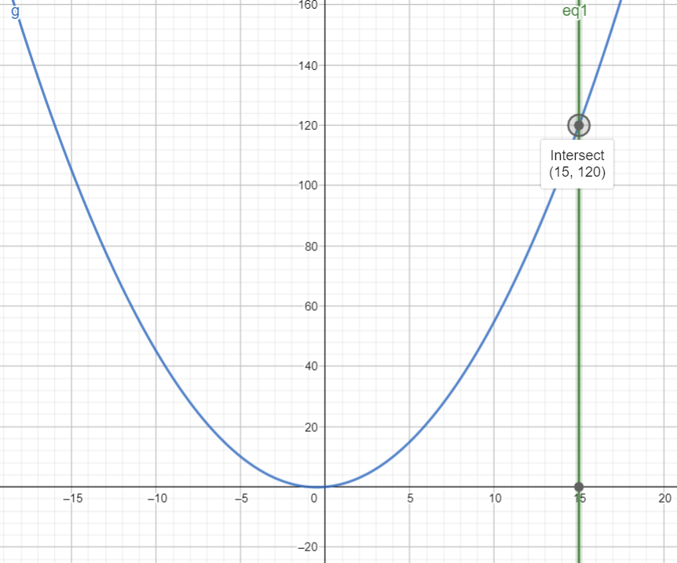

1. What we have if X = X +0.5 then

And

By defination f(X) have only one root at X = -0.5 and Y intersept = 1/8.

And Q(X) will have two roots X = -0.5 and X = -1.5 and Y intersept = 3/8 = 0.375.

So Q(X) at X = X +1/8 is the f(X) ; or Q(X) = f(X) -1/8

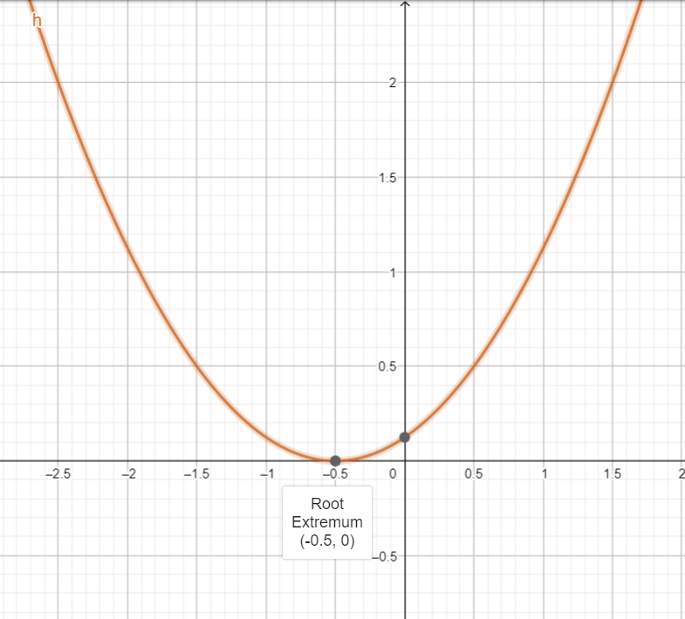

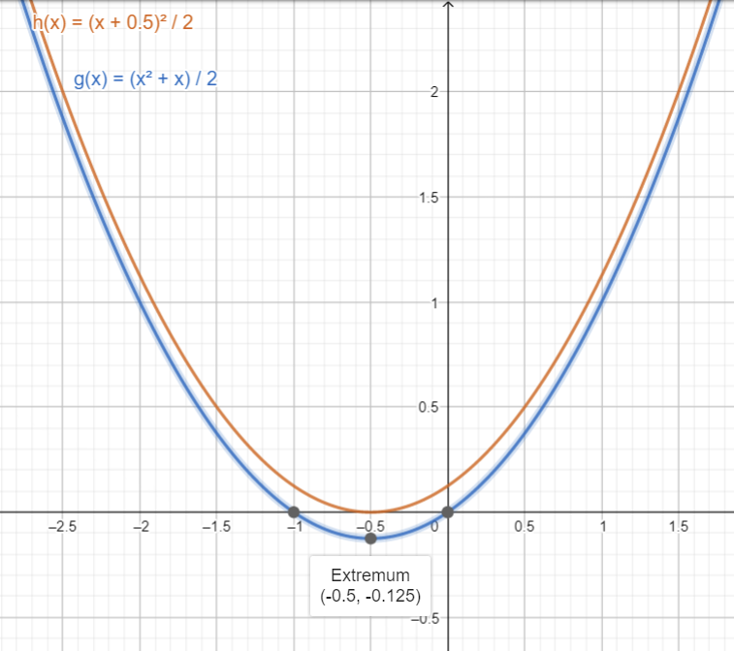

Just remember that h(x) here is f(X) which is the sum of all natural numbers as well but at X = X + 0.5.

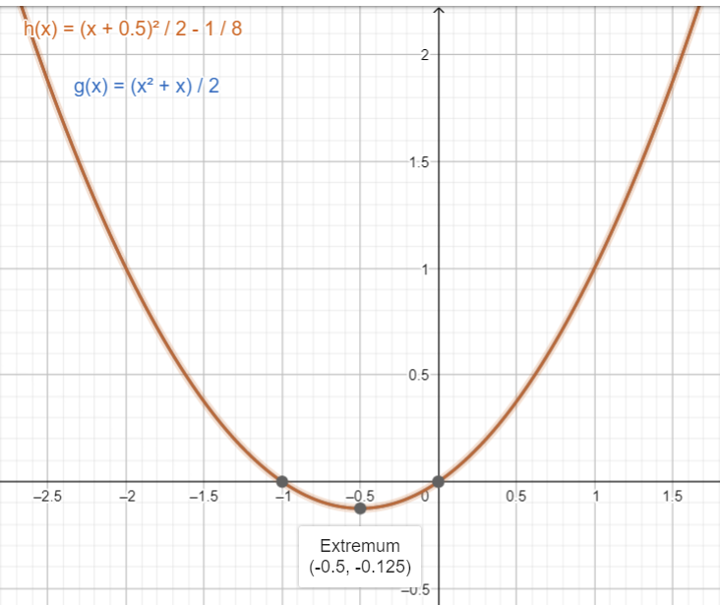

1. If any odd natural number multiply another odd number is an odd number (odd \* odd = odd)

Then for sure any odd number square will be an odd number (odd /2 = even + 0.5)

And if any odd number divide by 2 will be even number + 0.5.

Therefore, all odd number in will be even number + 0.5

; as we add again half the odd number; then all the time we will have a whole natural number.

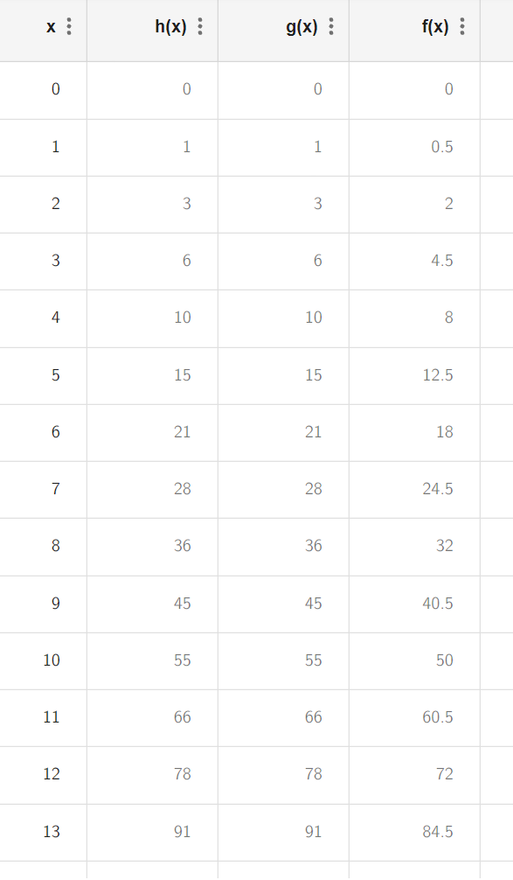

6 – f(X) at X = X + 0.5 but we transform it to the sum of all-natural numbers by adding 1/8 to f(X)

Then and f(X) = 0.5 at X = φ -1 and at X = -φ

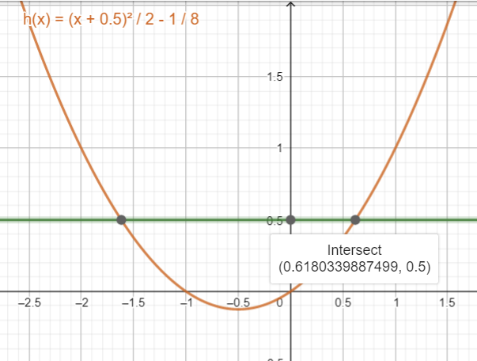

7 – we will use same transformation using π but not full value only the decimal part for π

So, f(X) will be

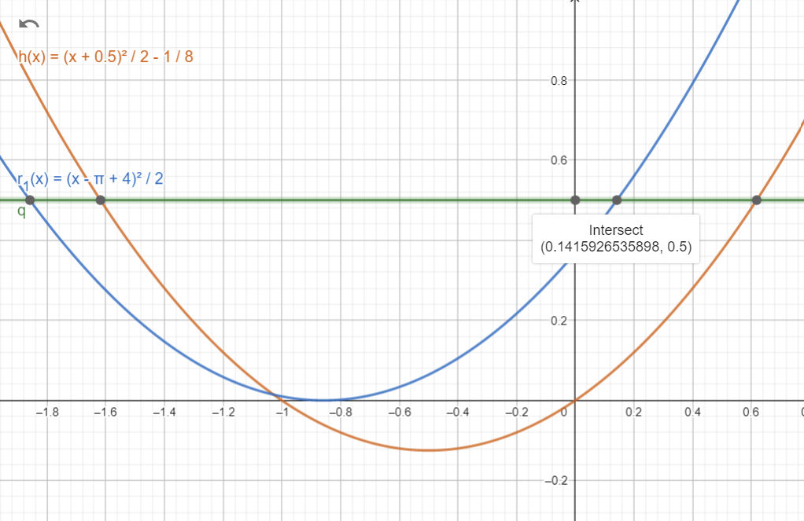At the curve for this f(X); at X = decimal part of π = π -3 then f(x) = 0.5

8- by doing this transformation we guarantee we have the decimal pert of π at specific point on the curve (first one is at y = f(X) = 0.5)

And as this function f(X) is half the square of natural number and we are interested in odd numbers

So, for X = 1 half a square will be at Y = 0.5

For X = 3 half a square will be at Y = 9 /2 = 4.5

For X =5 half a square will be at Y = 25/2 = 12.5

For X = 7 half a square will be at Y =49/2 = 24.4

For X = 9 half a square will be at Y = 81/2 = 40.5 and so on …

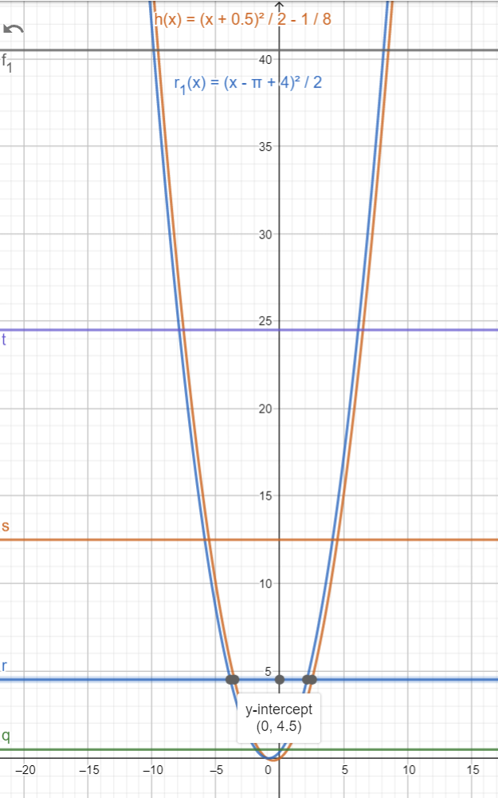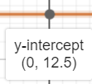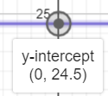

9- any line for Y value = (odd square number /2) + 0.5 = {0.5 , 4.5 , 12.5 , 24.5 , 40.5,…..}

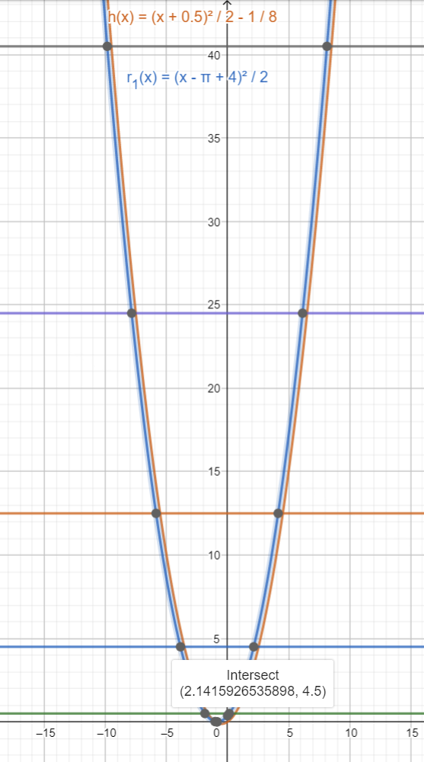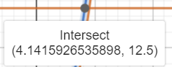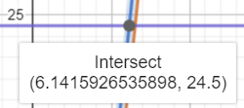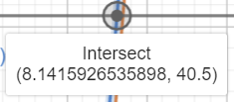

will intersect with sum function at points = {2,4,6,8,10, 12,…..} but with a decimal part = π -3.

10- for all our 4 transformations, the transformation curve will intersect with y = (x^2)/2 where x is odd number at some point. As you will notice we removed + 1/8 from h(x) so we get the root at X = -0.5

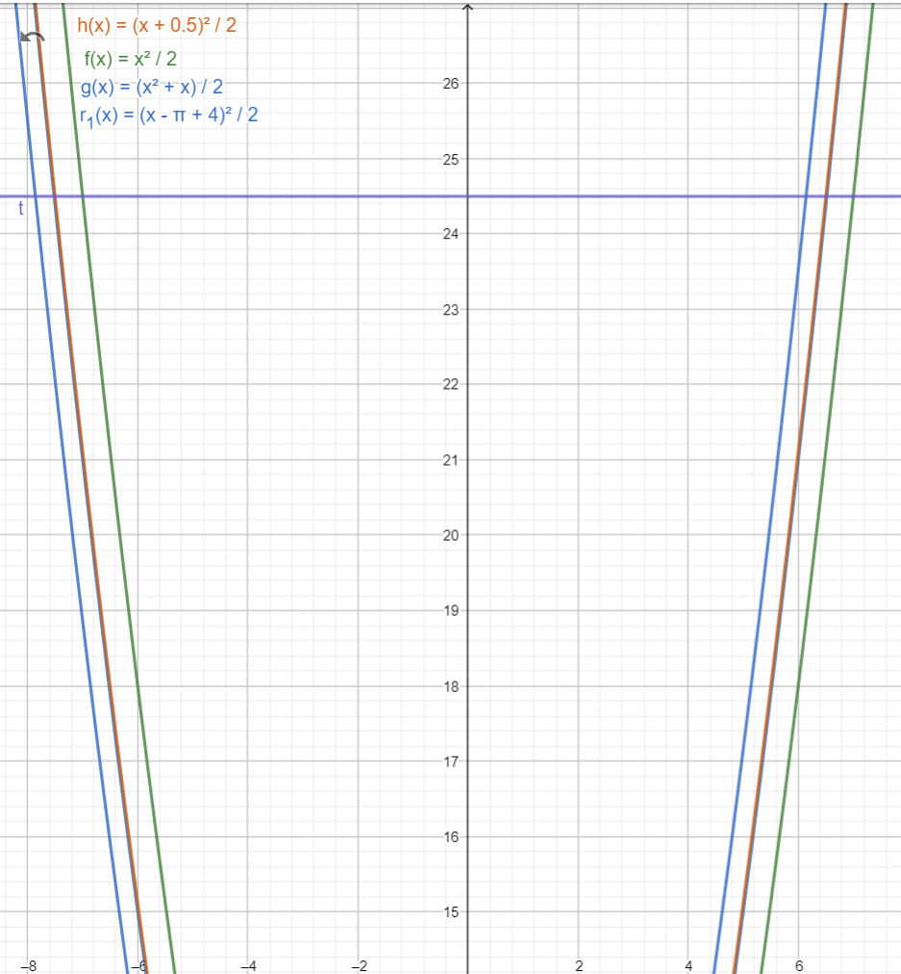

And we can do this transformation as well for the Sum of natural numbers by adding + 2/16 to it. So it will be exact equal to h(X).

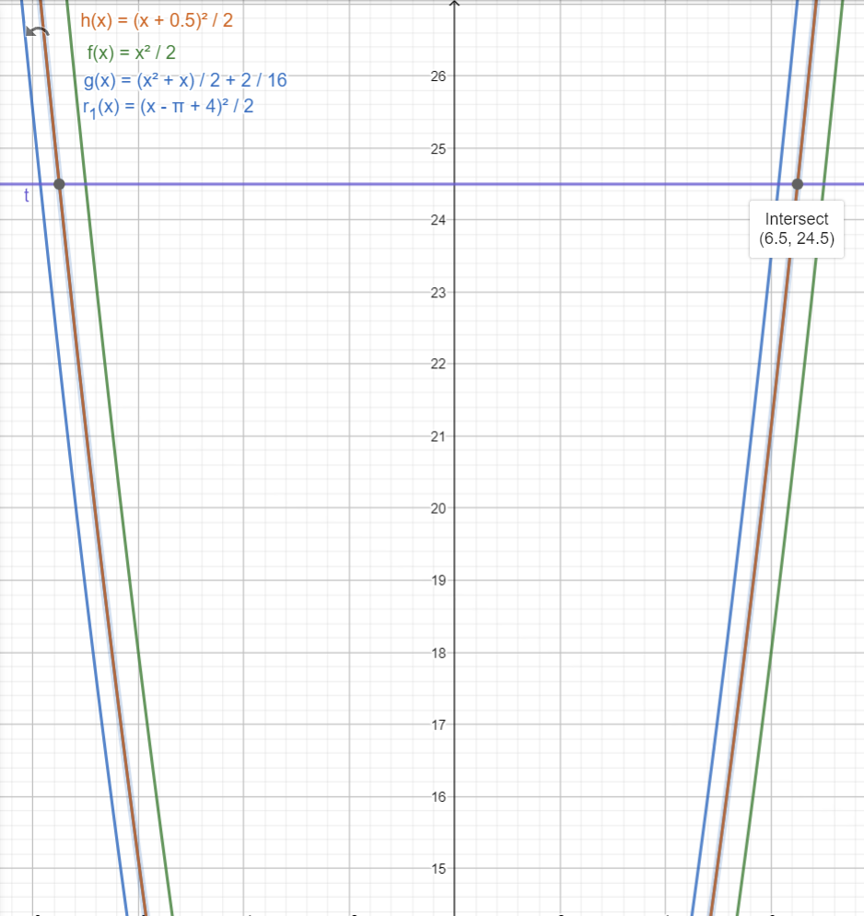

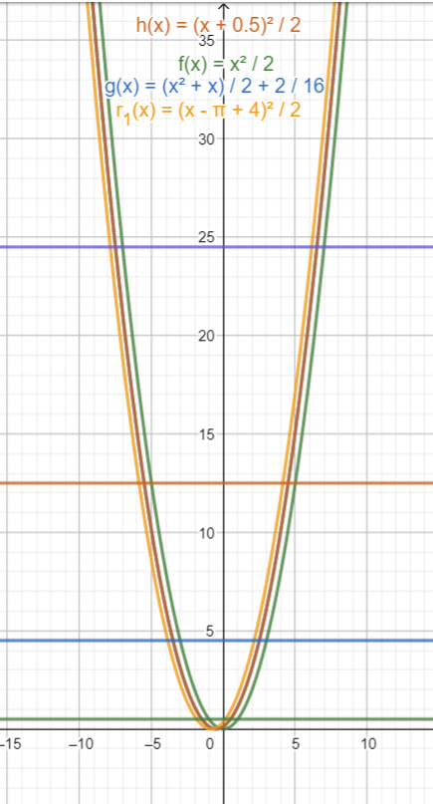

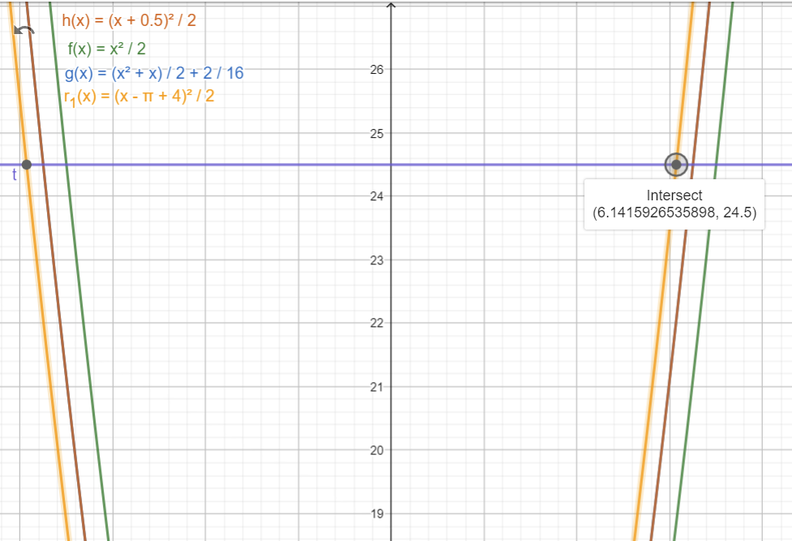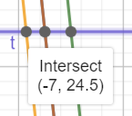

As we see here all odd numbers are lagged by 0.5 from its order and its square half value

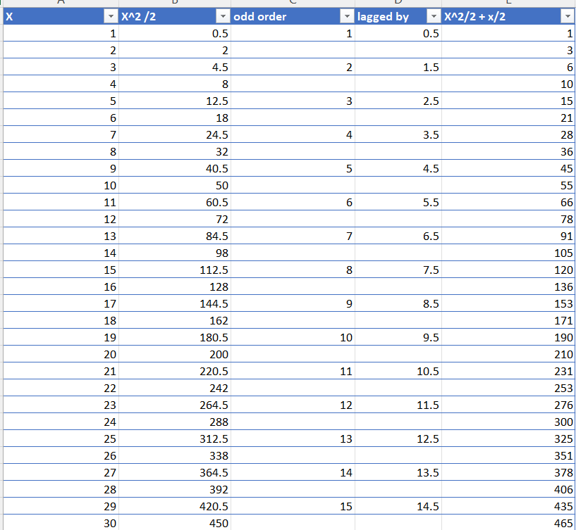

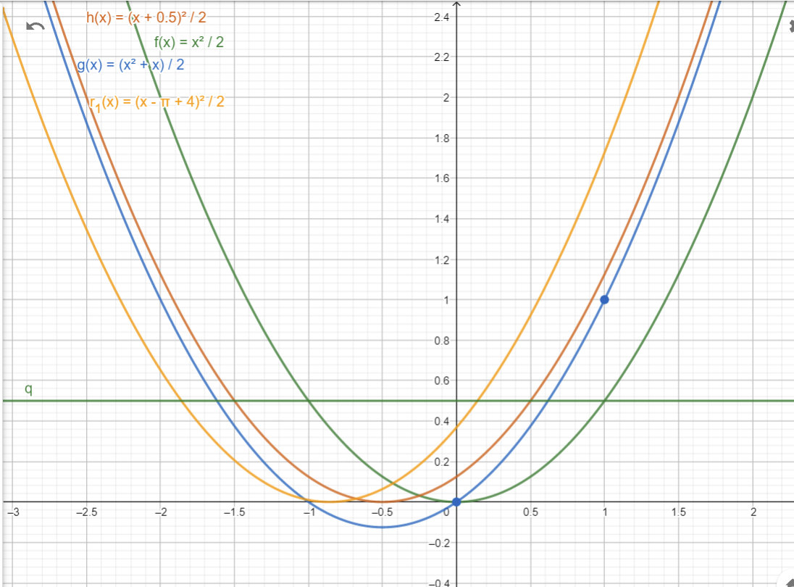

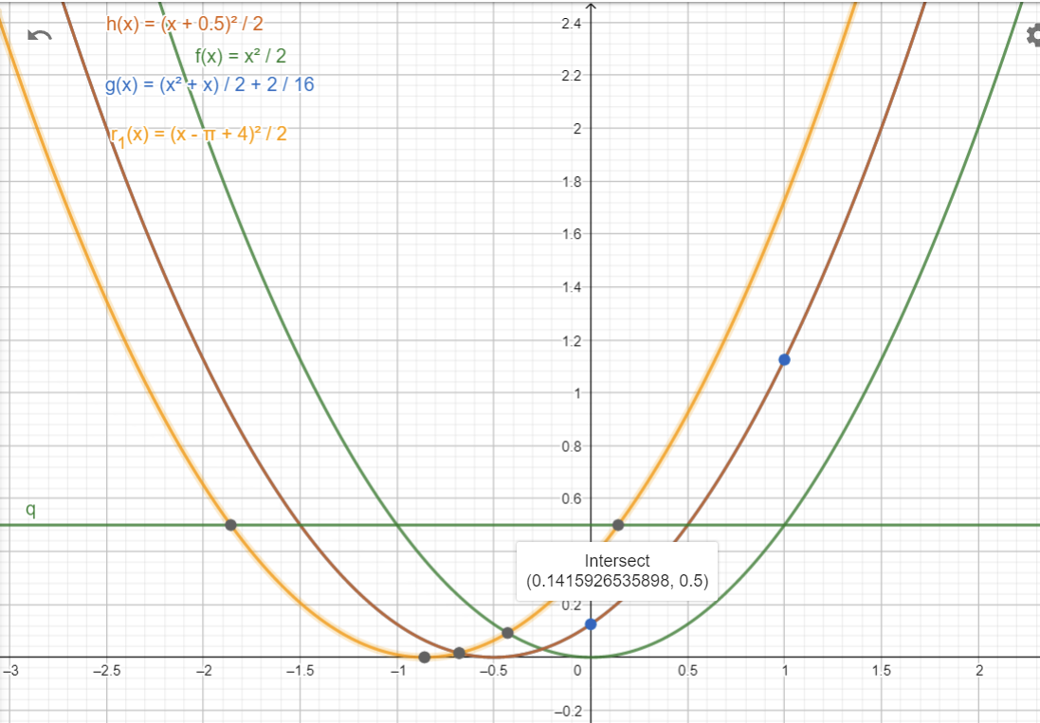And by adding 1/8 to the sum of all natural numbers function graph

So based on this

1. For All odd numbers intersection point between *Y =G(N) =*  ; and intersects with the sum graph at point = even number +0.5.

Where N = {1,3,5,7,9,11,13, 15…}

1. For All odd numbers intersection point between sum graph and *Y =G(N) =*  ; intersects at point = even number+ decimal part of π, i.e. (even number + π-3).
2. For All odd numbers intersection point between *Y =G(N) =*  ; and function

*Where intersection point number is even number + decimal part of π*

*i.e., Intersection points on f(X)= even number +π-3 = odd number +π*

*For each intersection with Y =G(N) =*

1. If Zeta function definition has and ; then for all odd numbers, zeta function will be equal to zero at the intersection point between these two functions

and *G(N) =*